INTERNATIONAL ORGANISATION FOR STANDARDISATION
ORGANISATION INTERNATIONALE DE NORMALISATION
ISO/IEC JTC1/SC29/WG11
CODING OF MOVING PICTURES AND AUDIO
ISO/IEC JTC1/SC29/WG11 M 12338
Poznan, Poland, July 2005

Title: | Test Sequences with Different Camera Arrangements for Call for Proposals on Multiview Video Coding
Status: | Proposal
Source: | Nagoya University , JEITA FTV Committee
Authors: | Masayuki Tanimoto (tanimoto@nuee.nagoya-u.ac.jp)  Toshiaki Fujii (fujii@nuee.nagoya-u.ac.jp)  Takanori Senoh (senoh@mpeg.rcast.u-tokyo.ac.jp)  Terumasa Aoki (aoki@mpeg.rcast.u-tokyo.ac.jp)  Yoshinori Sugihara (y-sugihara@jeita.or.jp)

Introduction

This document describes test sequences provided by Nagoya Univ. and JEITA FTV committee for Call for Proposals on Multiview Video Coding (MVC). We have developed "100-camera system" at Nagoya University and captured three test sequences with different camera arrangement: 1-D line, 1-D arc, and 2-D array. In the following, we describe the specification of the capturing system and the test sequences.

Capturing system and the sequences

The sequences were recorded by using "100-camera system" developed by Nagoya University (Intelligent Media Integration COE and Tanimoto Lab.). The system consists of one host server PC and 100 client PCs (called 'nodes') that are equipped with JAI PULNiX TM-1400CL cameras. The interface between camera and PC is Camera-Link. The system has one sync-generator that generates a synchronization signal and the sync signal is distributed to all the nodes.

We captured three sequences with different camera arrangements. The first sequence is 'Rena' captured with 1-D line arrangement, in which 100 cameras are aligned in a line with the camera interval 5cm. Hence, the viewing zone is 5 meters in length. The orientation of camera is set so that the optical axis of each camera is converged to one reference point near object. The second sequence is 'Akiko" captured with the half-round camera arrangement, in which 100 cameras are set in half-circle shape with radius 450cm. In this case, the camera interval is
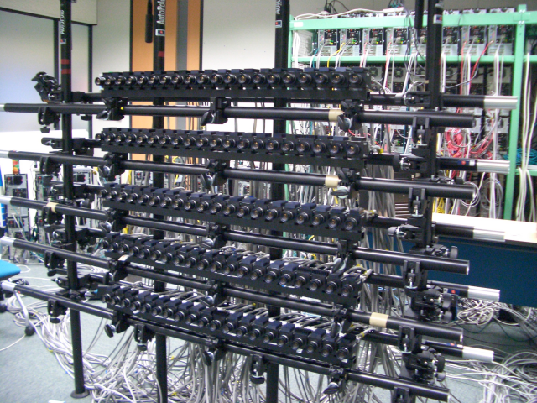
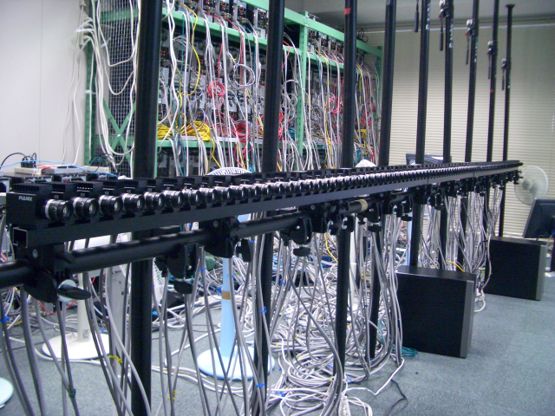
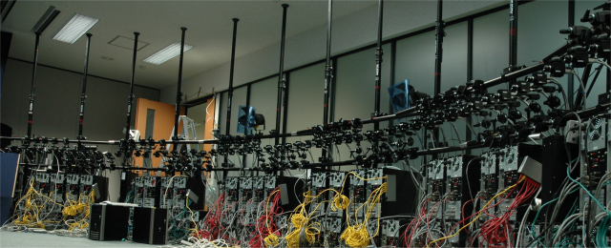

Figure 1: Three types of camera arrangements for capturing sequences with 100-camera system. Camera setups are: 1-D line (left), 1-D arc/half-round (middle), and 2-D array (right).
Table 1: Test sequences by Nagoya Univ. and JEITA FTV Committee

Data Set | Sequences | Image Property | Camera Arrangement
Nagoya Univ. | Rena | 640x480, 30fps  (rectified) | 100 cameras with 5cm spacing; 1D/parallel
Nagoya Univ. | Akiko | 640x480, 30fps  (non-rectified) | 100 cameras with 15cm spacing; 1D/arc (1.8 degree/view)
Nagoya Univ. | Akko&Kayo | 640x480, 30fps  (rectified) | 100 cameras (H: 5cm spacing x 20 columns and V: 20cm spacing x 5 rows; 2D array

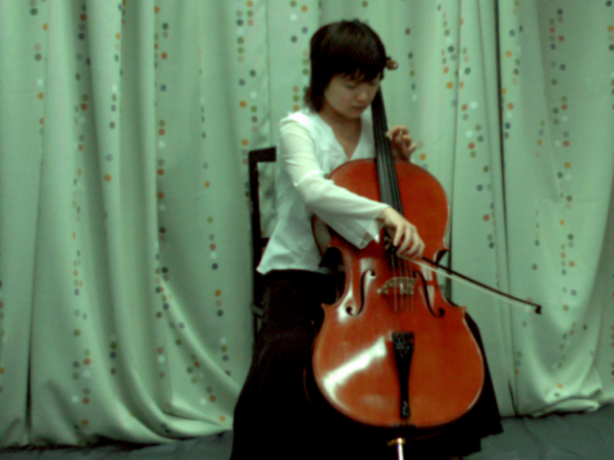
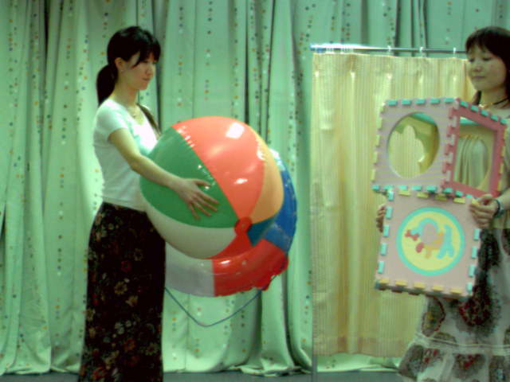
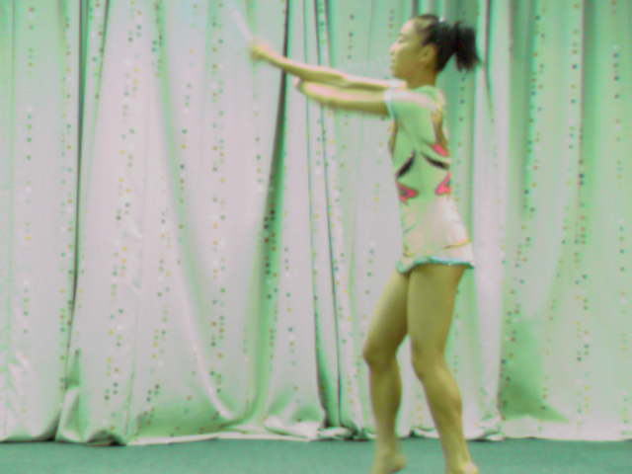

Figure 2: Test sequence ‘Rena’ (left), ‘Akiko’ (middle), and ‘Akko&Kayo’(right).

15.7cm. Camera orientation is set to 'converged' in a same way as the 1-D line arrangement. The third sequence is 'Akko&Kayo' captured with 2-D array camera arrangement, in which 100 cameras are aligned in 20(H) x 5(V) in camera interval 5cm and 20cm, respectively. The optical axes were set to parallel in this case.

Table 1 shows the specification of the test data. The original picture size is 1392(H)x1040(V) (progressive), and the frame rate is 30 frames/sec. The length of the original sequence is 60-150 seconds. The first step is the 'correction' of the original view images. For 'Rena' and 'Akko&Kayo' in which cameras are arranged in line or plane, rectification was applied. For 'Akiko', on the other hand, only registration using reference point and correction of camera orientation was applied. Then, the images were cropped and resized to VGA(640x480), and finally converted to YUV 4:2:0 format. We chose the VGA size to make the distribution of test data as easy as possible.

Image correction

As described in m12030, image correction prior to encoding and transmission is essential in terms of both high coding efficiency and usability for various multiview video applications. We therefore applied the image correction for three sequences as a common data set.

For 'Rena' (1-D line) and 'Akko&Kayo' (2-D array) sequence, ‘rectification’ and compensation for variation of camera intrinsic parameters were applied so that the image planes of all the cameras are parallel and intrinsic parameters such as focal length and scaling are the same among all the cameras. Through this transformation, the view images taken by the real camera setting can be converted into those that are captured by ‘ideal camera setting’; all the cameras have the parallel optical axes the same intrinsic parameters. Then, each image is shifted so that the projection of the reference point in 3-D space is fixed on the center of each view image. The amount of the shift determines the depth of zero-disparity plane and can be controlled freely. For 'Rena' sequence, the zero-disparity plane is set near the object. For 'Akko&Kayo' sequence, on the other hand, the zero-disparity plane is set to infinity. Note that all these geometrical transformation can be done by simply applying one 2-D projective transformation to each image. The parameters used for this transformation is solved by using a camera calibration technique. For 'Akiko' sequence, the same transformation described above was applied except 'rectification', because the rectification for 'arc' arrangement is useless. In addition to the 'geometrical correction', color and illumination correction is also applied.

Conclusion

We explained the test sequences provided by Nagoya University and JEITA FTV committee. Using '100-camera system' we have developed, we provide three nice sequences named 'Rena', 'Akiko', and 'Akko&Kayo'. You can download them at our web site:
http://www.tanimoto.nuee.nagoya-u.ac.jp/. The User ID and Password for authentication will be announced at the meeting.

References

[1] N6720, Call for Evidence on Multi-View Video Coding.
[2] N6910, Draft Call for Proposals on Multi-View Video Coding.
[3] N7094, Preliminary Call for Proposals on Multi-View Video Coding.

